Assignment: 2

# Comparison:

## Eggholder Function:

### Correct Solution: [512, 404.2319] = -959.6407

### Optimized Solution:

#### Case:

1. Population = 20, Generations = 200:

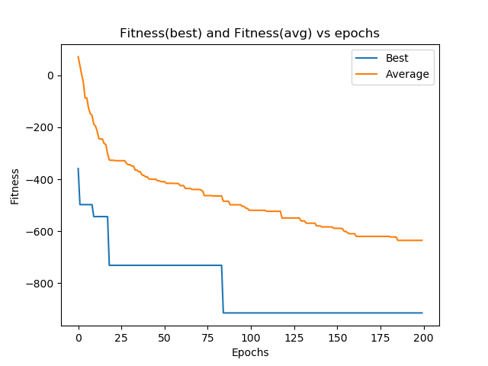

Solution Eggholder Function: [507.65612641, 404.28990221]

Population = 50, Generations = 200:

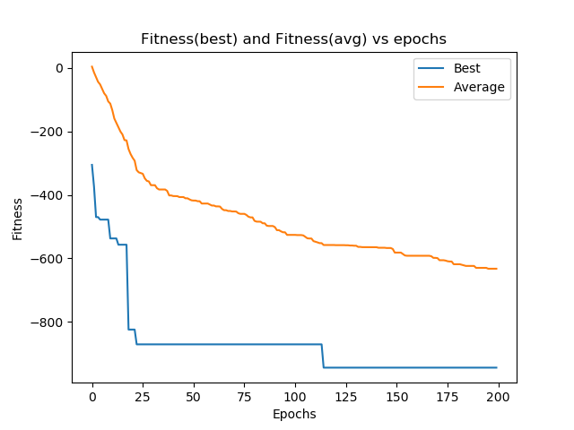

Solution Eggholder Function: [-465.56779994, 395.51859025]

Population = 100, Generations = 200:

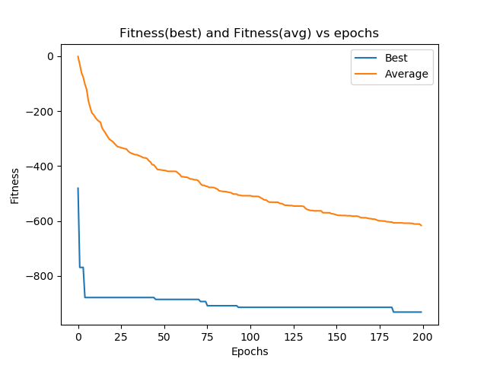

Solution Eggholder Function: [506.08908816, 395.61405746]

Population = 200, Generations = 200:



Solution Eggholder Function: [509.25488665, 403.01430561]

## Holder Function:

### Correct Solution: [8.055, 9.664] = -19.2085

### [-8.055, 9.664] = -19.2085

### [8.055,- 9.664] = -19.2085

### [-8.055, -9.664] = -19.2085

### Optimized Solution:

#### Case:

Population = 20, Generations = 200:

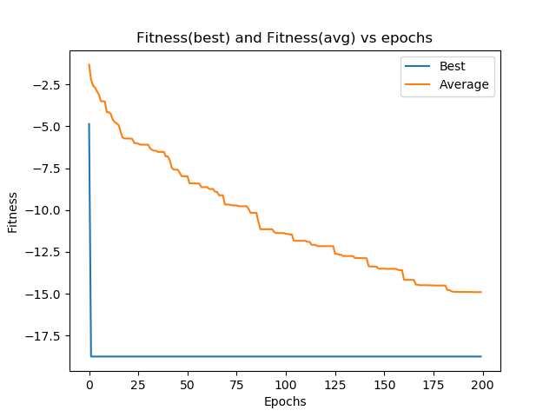

Solution Holder Function: [ 8.05436399, -9.63862704]

Population = 50, Generations = 200:

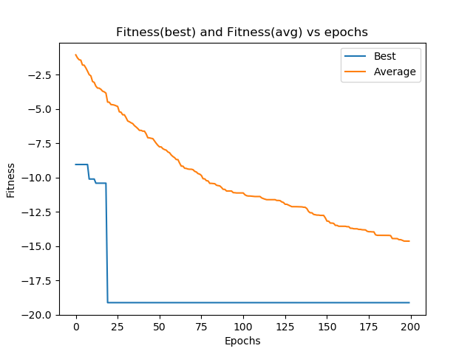

Solution Holder Function: [ 8.01316733, -9.68887543]

Population = 100, Generations = 200:

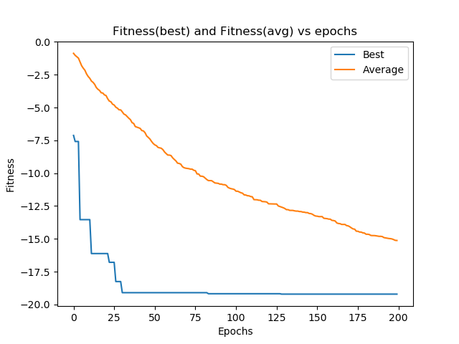

Solution Holder Function: [8.01302119, 9.6606593 ]

Population = 200, Generations = 200:

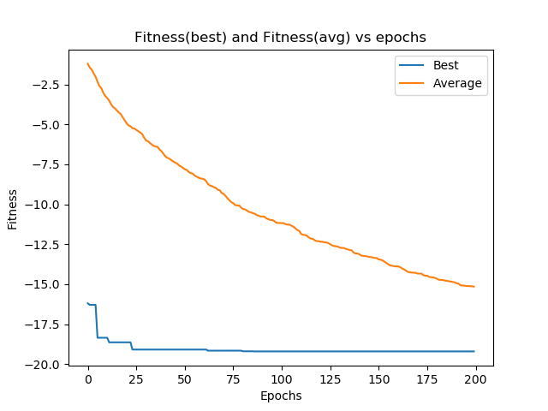

Solution Holder Function: [-8.04882139, -9.64311131]